Step: 1 Prepare One App from Visual Studio 2022

* Say hello app
* Buld and Run All test Cases
* If all goes ok
* Upload that app on github

Goto the github and copy the url

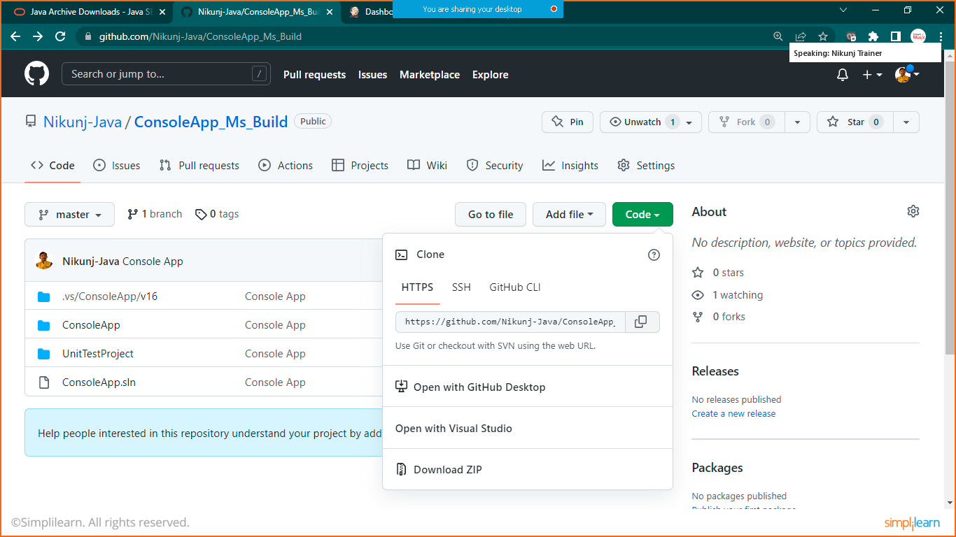

Console app Url:

https://github.com/Nikunj-Java/ConsoleApp_Ms_Build.git

goto Jenkins and click on create new job

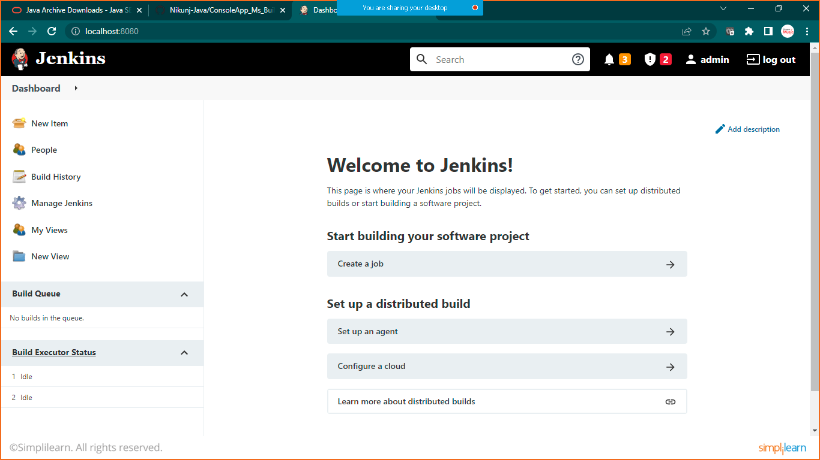

Give the name and choose freestyle project

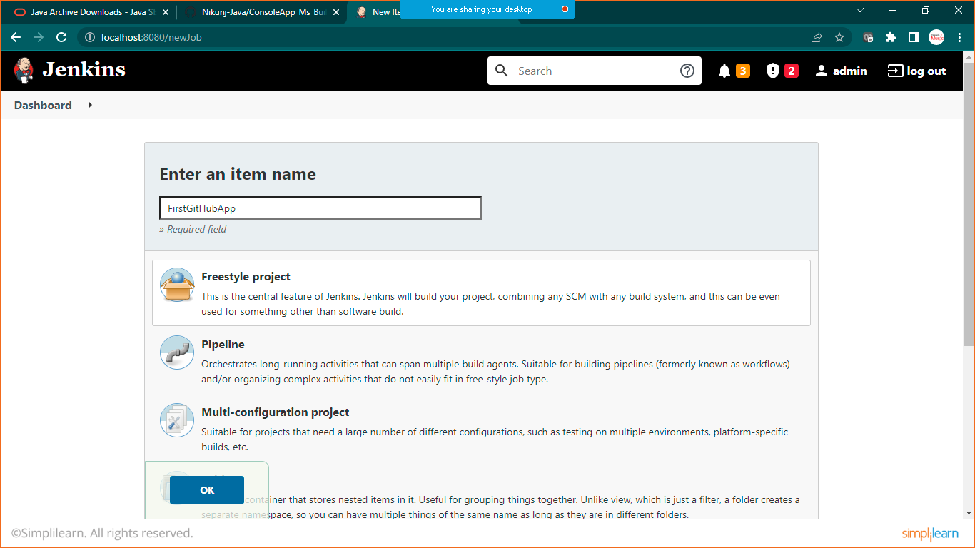

Now give description and other details like below

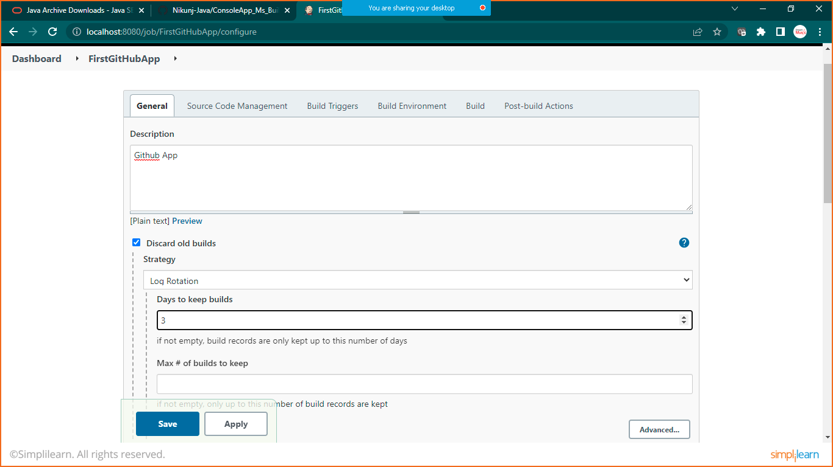

Check on Discard old build and set no of days as 3

Now in source code management

Paste your guthub url:

And set your branch as you have selected while preparing reposoitory

For me its master branch

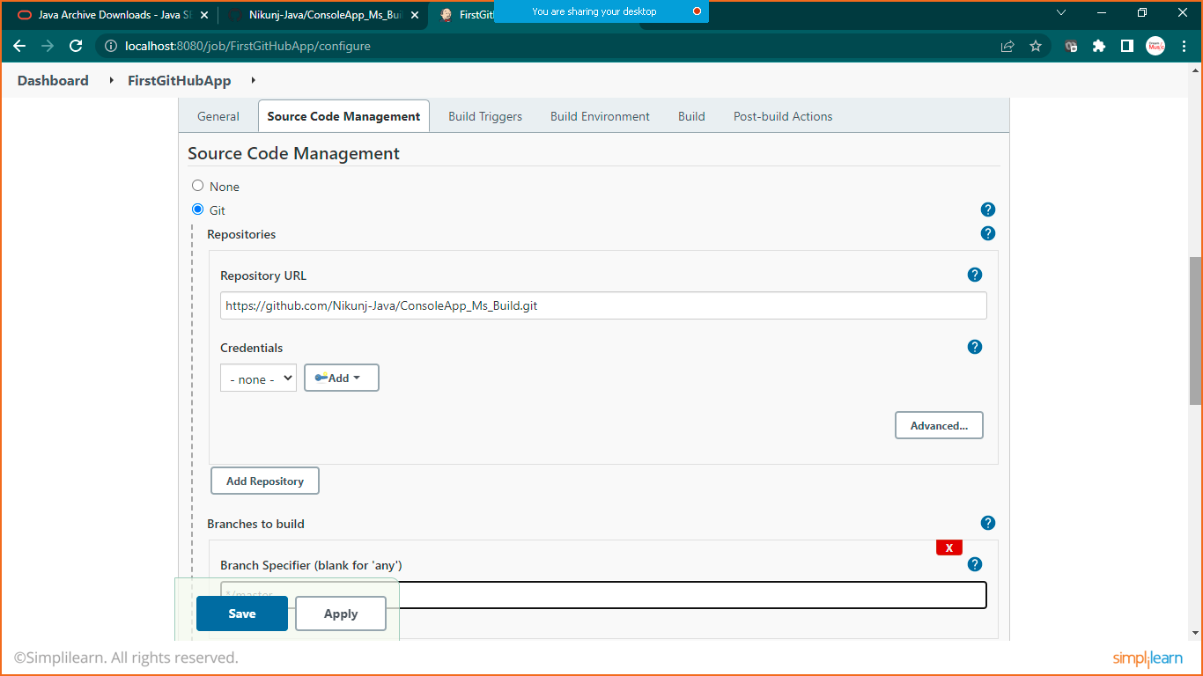

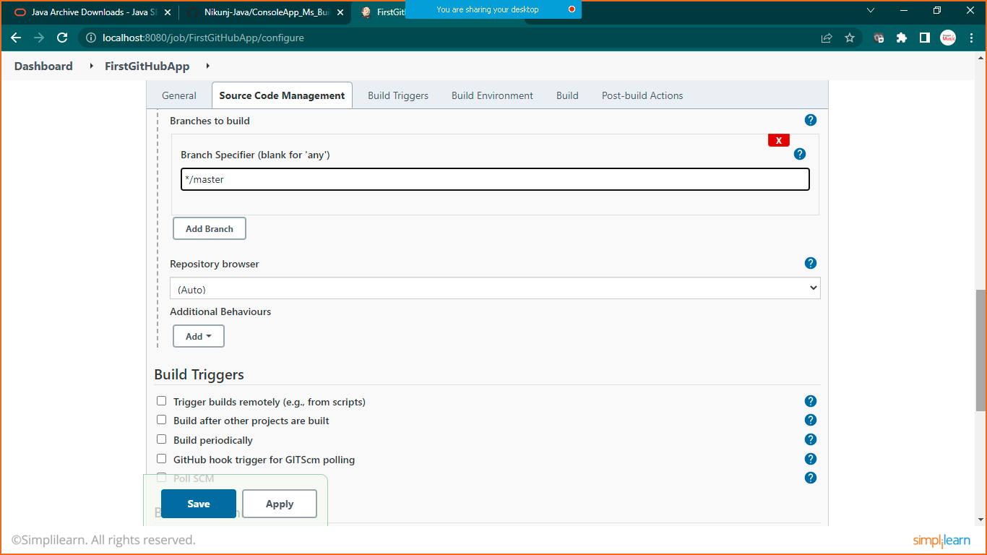

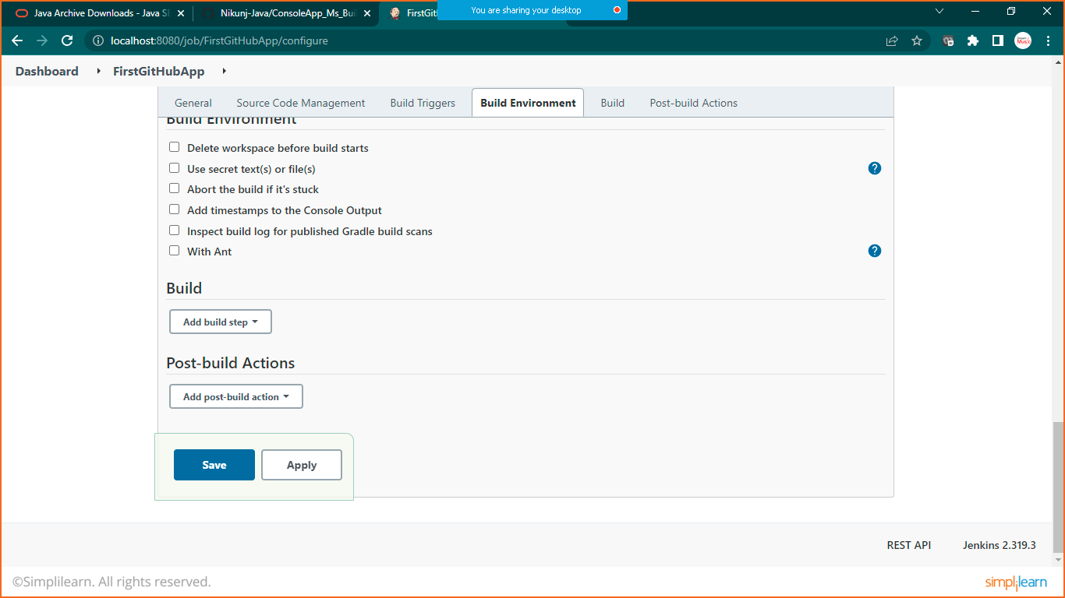

Click on apply and save

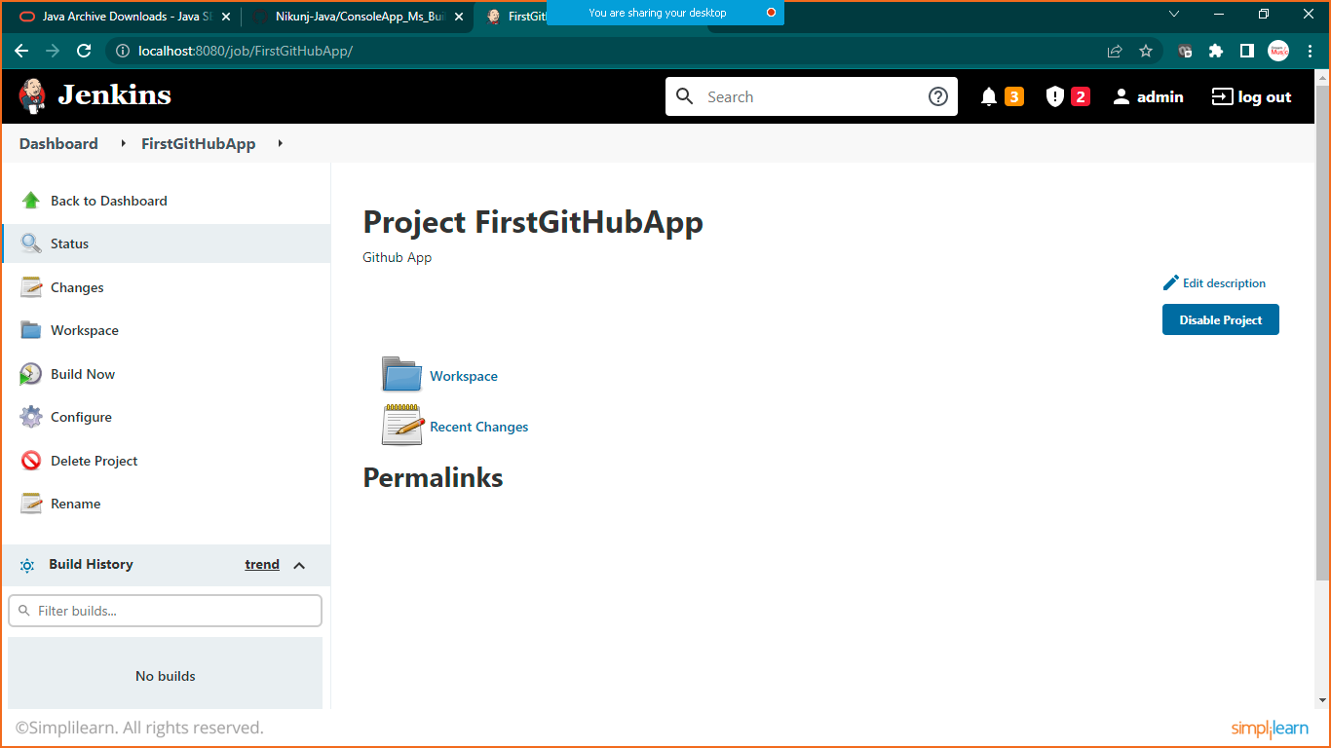

Click on Build Now

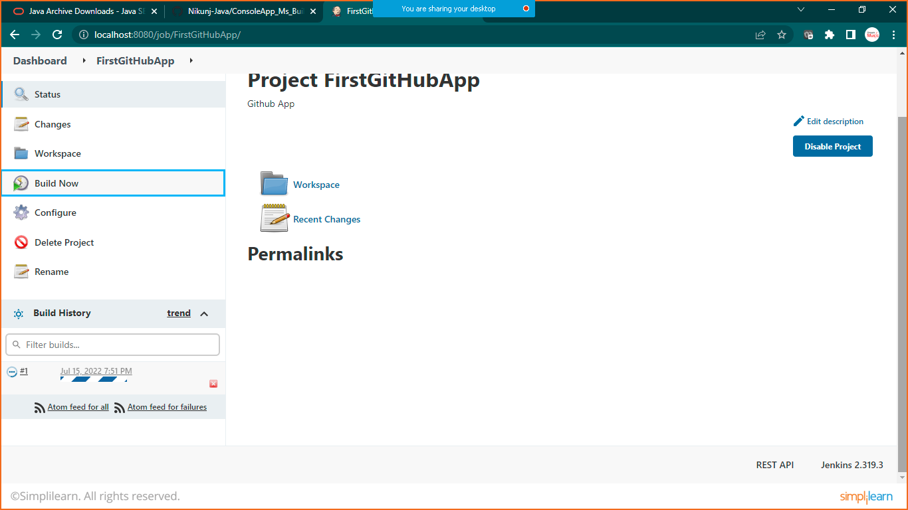

Onec it will finish you will see out put like below

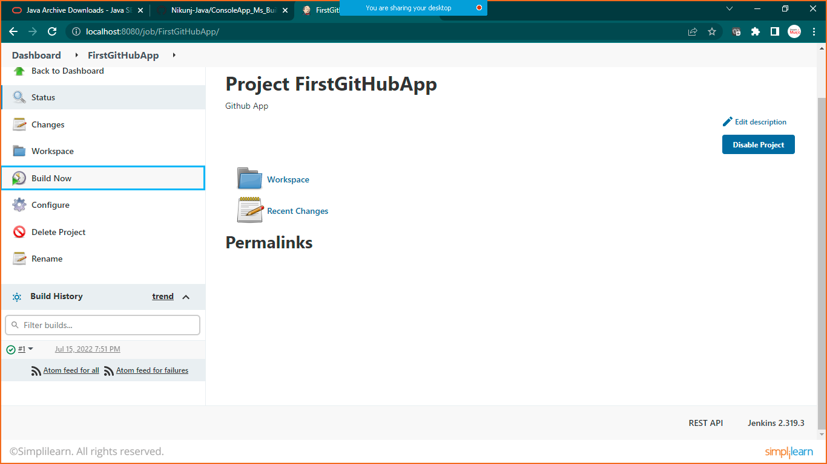

Click on #1 on build history, you will be redirected to build page

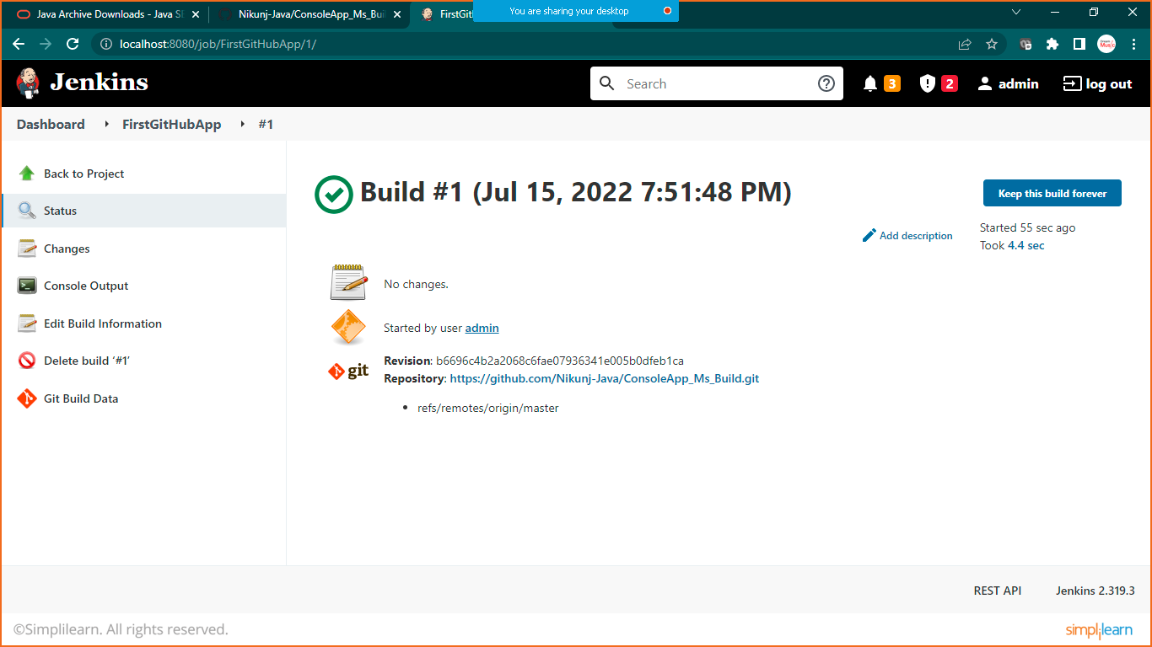

Click on console output

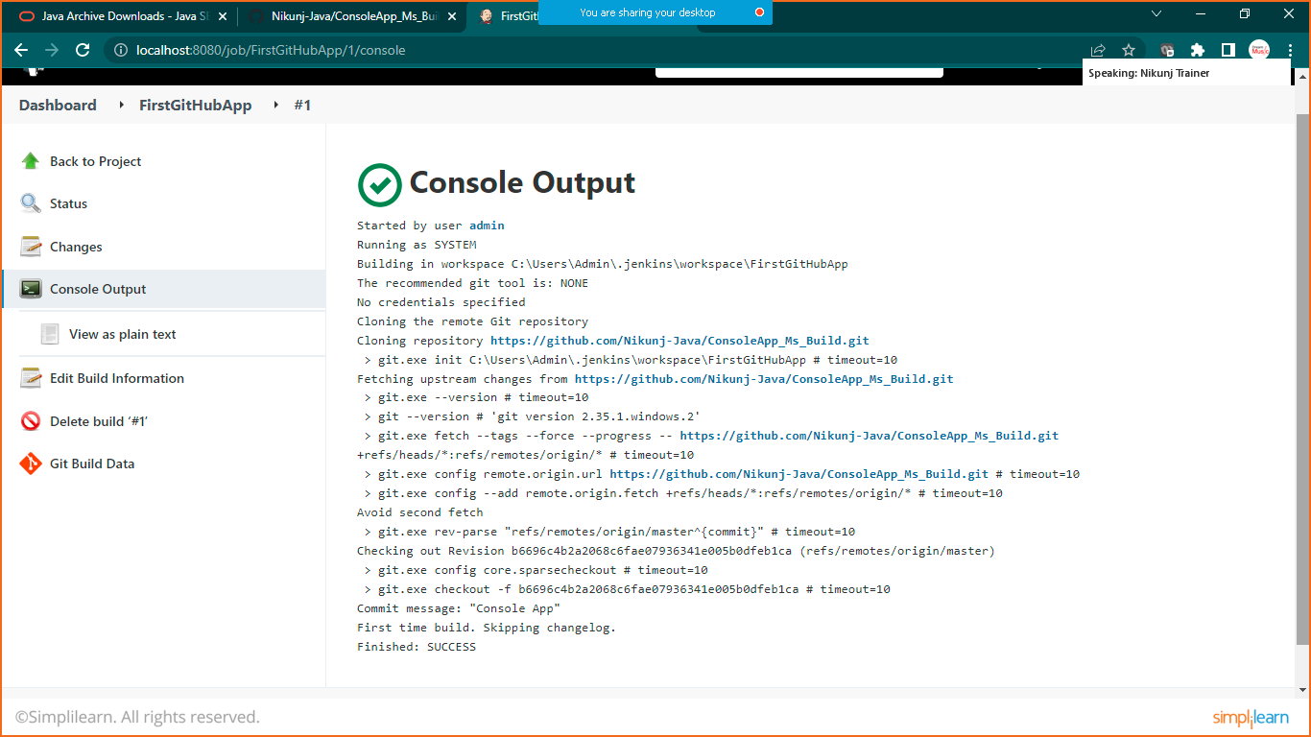

That’s it